**Name**: Rehabilitation and Intervention for Multiple Disabilities – (1) Prosthetic Environment

**Description**:

Intervention for persons with multiple disabilities will commence with creating an accessible and barrier-free environment that enables them to live and function without much difficulty and as independent as possible. The prosthetic features in the environment will depend on the nature of the component disabilities. In here, we shall discuss the essential accessibility and barrier-free features for disabilities of diverse natures.

**Prosthetic Environment and Barrier-free Features for Persons with Visual Impairment**

Environment for persons with visual impairment should enable them to move freely even when they are unable to see things around them. This means that the living and learning space should have a simple floor plan with only basic required objects such as furniture arranged in a neat and orderly manner. Passages and spaces where they move should have even and non-slip flooring, so that they do not slip or trip over. Also it is better to avoid obstacles or projections in the way, especially those that could not felt with their cane, such as open doors of windows, suspended cables, shelves projecting out of walls, etc. If such fixtures are unavoidable, then the persons with visual impairment should be previously oriented or cautioned about them, or they should be above head-level. Orientation and clues about the environmental features and barriers may be provided in the form of audio announcements, braille-signage, guiding rails and blocks, etc. For persons with low vision, good even lighting without glare or shadows will be helpful. Also use of contrast colours to differentiate different areas, sections, levels of flooring will help in easy mobility.

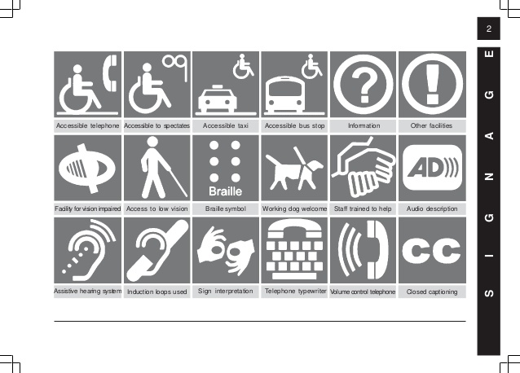

*Figure 1:* Barrier-free features for persons with visual impairment.

**Accessibility and Barrier-free Features for Persons with Hearing Impairment**

Persons with hearing impairment can be helped with an environment that enabled them hear more clearly. Maintaining low noise level, controlled reflection of sounds, and auditory information such as signals and speech being provided louder than the other sounds in the environment will be helpful in this regard. Installation and/or use of assistive listening devices such as FM, infrared or induction loop systems that will help persons with hearing impairment using amplification devices like hearing aids make better use of them. Even in such an assistive environment some persons with severe hearing impairment may not be able to hear clearly or comprehend spoken information. For the benefit of such individuals good lighting and visibility of the source of information should be ensured. For example, the mouth and facial features of the teacher or anyone speaking should be visible without shadows, being hidden or turned away. The lip movements and facial expressions may provide helpful visual clues to supplement the spoken information. Moreover all verbal information can be supplemented visually. For example, spoken information may be accompanied with board writing or manual gestures, audio information can be accompanied with captioning, videos can come with subtitles, etc. It should be ensured that these visual or printed information should be displayed in large readable size, good background-figure contrast, at eye level and without shadows or glare on them.



*Figure 2:* Barrier-free features for persons with hearing impairment.

**Prosthetic Environment and Barrier-free Features for Persons with Physical-Motor Impairments**

For persons with lower limb deformities evenly levelled, non-slip flooring with wide doorways will be helpful when moving with help of artificial legs, crutches, or wheelchairs. Steps and staircases can be supplemented with ramps and elevators/lifts. Hand-rails and curbs along passages will provide support as well as prevent trip or slip beyond the pass ways. There should adequate positioning space for wheelchairs and convenient holds for crutches near the seat of work. Environmental devices such as handles, switches, taps, telephones, etc.; should be at reachable heights for persons sitting in wheel chair or persons who cannot raise their hand too high taking them of the crutches. For persons with upper limb deformities, these devices should be easily operable with least possible effort. Further provision of grasping and handling devices such as pencil grippers, page turners will be helpful in holding and manipulating materials and tools in the learning environment.

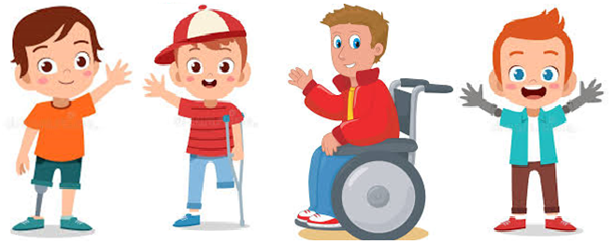

*Figure 3:* Barrier-free features for persons with physical-motor impairments.

**Prosthetic Environment and Barrier-free Features for Persons with Behavioural and Cognitive Impairments**

For children who find it difficult to comprehend directions and information in the learning environment, the floor plan should be simple with all utility spaces demarcated clearly. For example, their seating could be marked with a photo, classroom boundaries or prohibited areas with red tape, etc. Some children might have difficulty in reading comprehension, for such children all signage such name boards or labels could be accompanied with visuals or iconic symbols. If there are children with difficulty in controlling their behaviours and focusing attention on the learning tasks, then it is necessary to ensure that the environment is distraction free. For children who exhibit problem behaviours like tantrums it is necessary to avoid bare or spare spaces to exhibit problems, to provide seating that restricts uncontrolled movement, and make sure that the furniture and materials in the environment are durable and damage-resistant.

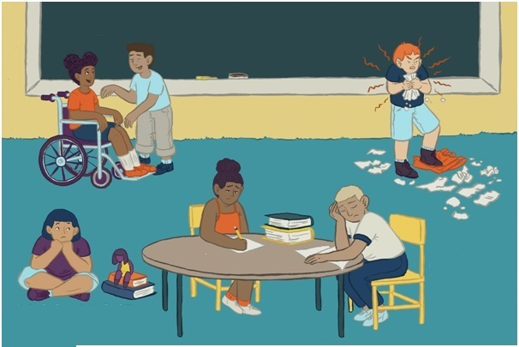

*Figure 4:* Barrier-free features for persons with behavioural and/or cognitive difficulties.

**Name**: Rehabilitation and Intervention for Multiple Disabilities – (2) Positioning, Seating & Handling

**Description**:

Normal posture and positioning of children with multiple disabilities may be affected due to presence of – sensory impairments, physical-motor impairments, or associated sensory issues. This section shall shed light on handling such issues.

**Considerations for Positioning Children with Multiple Disabilities**

When positioning, seating or handling children with multiple disabilities, utmost care should be taken to keep them safe and make them feel comfortable. The positioning should be in such a way that they are enabled to be as alert as possible, and be able to make use of their residual abilities and function optimally. Positioning should also ensure that inherent pain if any should be reduced as much as possible and secondary complications should be avoided. Care for ensuring safety and prevention of secondary complications of their complex and/or severe problems should not lead to isolating them from their typically developing peers. Social integration in a barrier-free learning environment should be promoted as much as possible.

When positioning children with multiple disabilities, lying, sitting or standing positions may be considered according to their inherent residual abilities to maintain those positions and function effectively from those positions. In whatever position the children are stationed, verticalisation should be ensured. That is, the parts of body above those resting should be maintained as erect as possible for conserving health and better ability to carry out work. As much as possible the head should be raised with support enabling the child become aware of what is happening around, and the hands should be free to handle things and do work that is feasible.

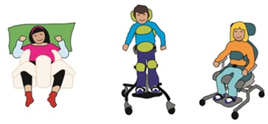

*Figure 5:* Positioning of children with multiple disabilities.

**Seating Arrangements and Sitting Positions for Children with Multiple Disabilities**

Children predominantly are seated while pursuing learning activities either at school or home. According to the convenience of the children and the facilities available in the environment, the seats could be arranged at floor level or at a raised level. Whatever the level, try to maintain 90° angular position at major joints such as hips, knees and/or ankle with the head slightly tilted forward over the work surface. Seating can be custom-made according to the needs of the child.

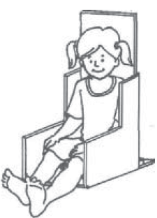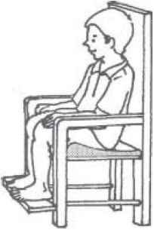

*Figure 6:* Seating for children with multiple disabilities.

Seating should also provide custom-made supports for the affected parts of the body such as – bands, belts or buckles to hold the body parts that tend to slip or fall out of place; cushions to support weak parts that are vulnerable to pain; back rest extending beyond even up to head level depending on the level of trunk and head control; trunk block or angular seats to avoid spinal deformities; rests for arms and legs if they are weak to support themselves; and separators to keep legs apart without contractions among others.

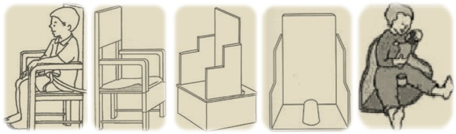

*Figure 7:* Custom-made modified seating for children with multiple disabilities.

Seating facilities need to accommodate additional accessories that will promote easy and independent functioning of children with multiple disabilities. For example, using a wheel chair or attaching castor wheels to custom-made wheel chair will facilitate free mobility in children. Attaching a lap/work tray to the chair will provide comfortable work space for the children.

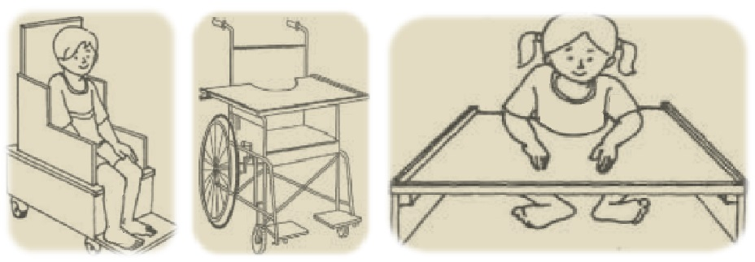

*Figure 8:* Seating accessories to help children with multiple disabilities.

Mostly children with physical-motor impairments as a component of multiple disabilities may require the above-mentioned adaptations in seating. Nevertheless, children with other disorders of sensory or neuro-developmental nature may also benefit from preferential seating arrangements in learning environment. If they are seated closer to the teacher and other sources of information in the front of the class at about 6 to 10 feet distance, and within a field of 45° horizontal angle. The vertical angle between the level teacher’s face and that of the students should also be not more than 30°. Such an arrangement will allow the children to observe and follow the teacher closely in spite of having difficulty in seeing or hearing. The teacher will also be able to maintain frequent eye contact and direct individual attention when necessary especially for children who are slow to grasp instruction or get distracted and disturbed easily.

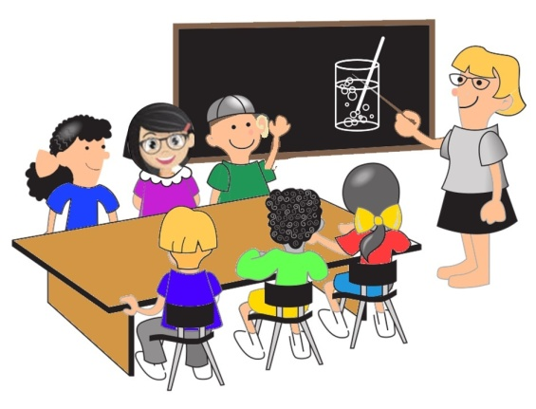

*Figure 9:* Preferential seating for children with multiple disabilities.

**Arrangements for Learning and Working from Standing Position**

Certain children with multiple disabilities facing complications like muscle contractures or gravity problems may feel comfortable in standing position. In such conditions, necessary arrangements may need to be made to enable participation in learning activities and carrying out other essential functions from standing position. Inclined boards, as well standing frames will help children learn and work from vertical or slanting position. Standing frames with accessories such as work trays and wheels for mobility will further enhance easy and effective functioning.

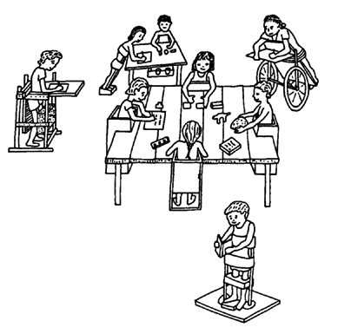

*Figure 10:* Children with multiple disabilities learning/working from standing position.

**Provisions for Learning and Working in Lying Position**

Many children with severe multiple disabilities may not be able sit or stand for a long time, or sit or stand at all. In such situations, provisions should be made to enable them to learn from lying position. Generally this may not come about in the mainstream learning environment, but usually in special learning environment or in home-bound instruction. In such situations according to the health conditions and/or convenience of the children, three varied positions may be considered, namely, prone, supine or turned positions. Whatever the posture, maintaining the head in a raised position so as to see the person who is instruction and teaching-learning materials used, as well as what is happening around oneself is necessary. Also it will be advantageous to keep the hands free to manipulate the teaching-learning aids in use. As in sitting or standing position, weak and vulnerable parts of the body have to be protected and supported. For children who need to be in lying position for prolonged duration, arrangements could be made to make them mobile in that position. Attaching small castor wheels to boards for lying could convert them into floor-scooters on which children could move around in lying position. However spacious, hazard-free environments are necessary for floor-scooters to move around freely without risk.

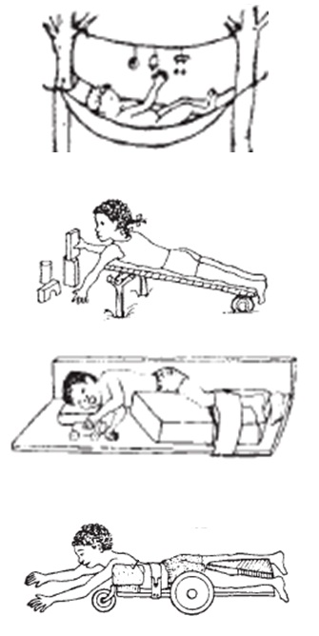

*Figure 11:* Children with multiple disabilities learning/working in lying position.

**Handling Children with Multiple Disabilities**

Handling is the way children are picked up, carried and put down when children are made to change from one position to another, or transported from place of learning/working to another. The mode of handling children with multiple disabilities varies from child to child, according to the predominant nature of the disabling condition, and the immediate environmental conditions and facilities available. There are some general considerations that should be kept in mind when handling any child with multiple disability Children should be handled carefully with two hands balancing all sides of body evenly, and not be dragged or pulled along one side. Care should be taken to support the weak parts of the body keeping in mind specific health risks and safety precautions essential according to the composition of disability in each child. Along with ensuring physical safety, psychological comfort of the child should also be taken care when handling them. Whatever position children are handled in and however brief the duration may be, it should be ensured that they are enabled to be alert and aware of the environmental entities and events, while with their hands having something to hold on or being as active or functional as possible and necessary. If the children being handled are having problems with stiff muscles, then it is better if their limbs are separated and astride. If the children have floppy muscles, then they can be carried in cradling position, while their weak body parts are being supported. If children have associated sensory issues such as pain or lack of visual orientation then care should be taken to avoid exertion of pain and consideration to inform them of arrangements and events around. Along with ensuring physical safety and functionality, provisions should be made for preserving emotional security and personal dignity appropriate to age and gender of the children, and social situations.

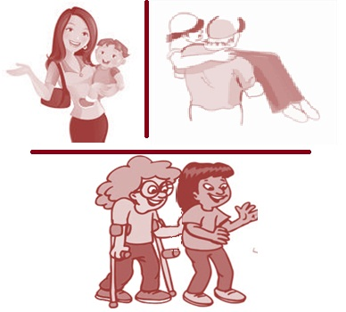

*Figure 12:* Handing children with multiple disabilities.

**Name**: Rehabilitation and Intervention for Multiple Disabilities – (3) Facilitating Teaching-Learning with Individualised Educational Programme along with Teaching-Learning Materials and Assistive Technology

**Description**:

Learning ability in children with multiple disabilities may be severely restricted. Hence, purpose and process of education has to be decidedly individualised according the nature of impact of the disabilities and the needs of the individual children. Success of the individualised educational programme may require use of appropriate assistive technology to overcome the limitations of the disabilities and facilitate optimal use of the residual abilities. Along with these use of special teaching-learning aids may enhance the effectiveness of the instructional process.

**Individualised Educational Programme for Children with Multiple Disabilities**

Children with multiple disabilities may not always be in position to learning regular academic lessons as taught in mainstream schools. In such situations an alternate curricula that is appropriate to their differential abilities and practically useful according to their life needs are individually for the children. Such individualised educational programme (IEP) will focus on developing life skills necessary for independent, community living such as – adaptive behaviour, self-care, orientation and mobility, and communication skills. With these training in functional academics, as well as productive skills as part of vocational and/or leisure training may be added. Development and implementation of an appropriate IEP as for any other disability will comprise forming an IEP team with necessary educators, rehabilitators and caregivers; gathering information about the children, setting long-term and short-term goals, designing and executing the individualised educational plan, and periodical evaluation and review of its realisation.

In the process of implementing an IEP for children with multiple disabilities, it is necessary to incorporate appropriate instructional strategies according to the nature of component disabilities. Generally the impact of combined disabilities may manifest in the form of sensory, motor and/or cognitive limitations in the functioning of children affected by them. For children with sensory impairments a multisensory approach that augments their residual sensory abilities (such as magnification facilities for children with low vision, amplification aids for children with hearing impairment, etc.); along with supplementation of information through diverse sensory channels (such as auditory information for children with visual impairment, and visual information for children with hearing impairment) has to be adopted. Provisions should be made for assistive technology necessary for augmenting residual abilities and alternating sensory channels.

For children with problems in motor functioning, performance tasks need to be broken down into smaller activities. These children may need more time to complete these smaller tasks over several short sessions with frequent breaks in between. If carrying out the physical tasks are difficult even with such simplification of work process, then the children need to be permitted to adopt alternate modes of participation in the instructional process, for example responding orally instead of writing. Provisions for necessary human assistance such as scribes for writing down their oral responses, or technological supports such as software for speech-text interfacing should be made. For children facing challenges in behavioural and/or cognitive functions will benefit from life-oriented learning targets that are implemented through functional and structured instructional routines. These children may also need to be permitted more time for comprehensive exposure and recurring exercises before they are able to accomplish the instructional objectives. If intellectual limitations make instructional attainment improbable with all these accommodations, then moderation of the difficulty level of learning tasks and concessions in the assessment procedures may need to be considered.

As children with multiple disabilities in several instances are affected with associated health issues such as epilepsy, provisions for handling emergencies should be part of the individualised contingency. This implies maintaining a healthy and safe learning environment where the physical and psychological health of the children is constantly monitored. And staff are prepared with necessary training and facilities to meet probable health emergencies.

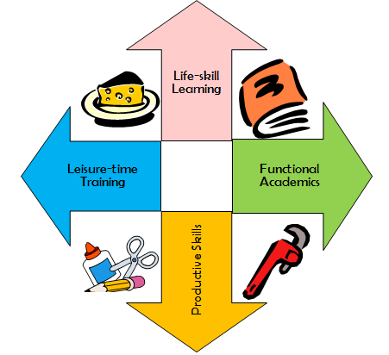

*Figure 13:* Focal areas of individualised educational programme for children with multiple disabilities.

**Use of Special Teaching-Learning Materials and Appropriate Assistive Technology in the Instruction of Children with Multiple Disabilities**

As universally acknowledged, teaching-learning materials are used in the instructional process both by the teachers as well as learners to enhance the efficiency of teaching and/or enrich the effectiveness of learning. When developing or choosing and using teaching-learning materials with children with multiple disabilities, it is necessary to ensure that they are accessible to the children physically, while they are safe to use. It is better if the instructional materials are custom-made according to the individual child’s learning style and needs. It will be advantageous if the materials provide multisensory stimulation and information for children with sensory limitations, and if they are handle-able and easily operable with minimal effort for children with limitations in motor functions. Instructional materials for children with limitations in cognitive functions need to facilitate functional learning through diverse learning experiences.

**Assistive Technology and Educational Aids for Children with Multiple Disabilities Having Difficulty in Seeing**

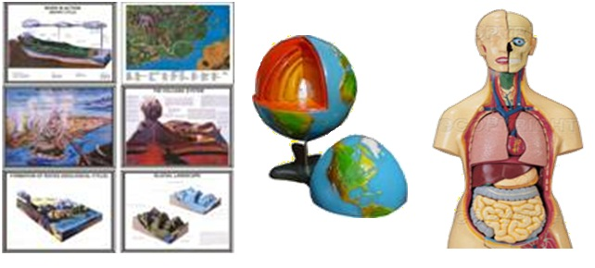

*Figure 14:* Tactile and manipulative teaching-learning aids for children with multiple disabilities including visual impairment.

Children with multiple disabilities comprising visual impairment either low vision or profound impairment will benefit from teaching learning aids that provided tactile information such as – illustrations with textured or embossed surfaces. Moreover if the aids are manipulative where the children can operate them to gain practical learning experience it will be better. Further children with low-vision might require accessories such as magnifiers, special lighting and contrast coloured highlighting. While children with profound visual impairment will need braille aids such as the conventional slate and stylus, brailler, etc., or digital aids such as computers with software for braille-to-speech/text conversion along with accessories such as refreshable braille display and braille printers.

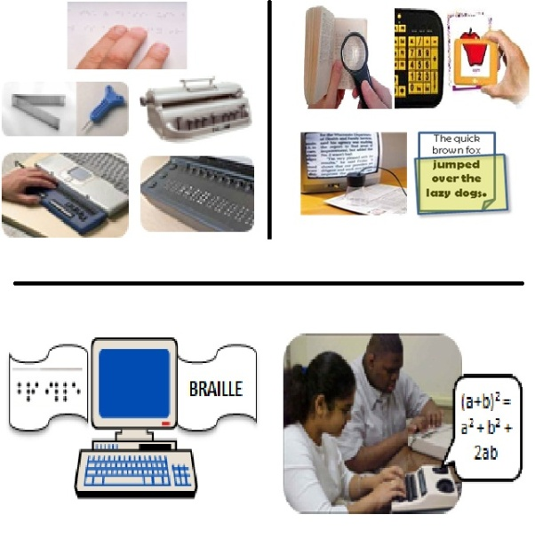

*Figure 15:* Braille and magnification aids for children with multiple disabilities including visual impairment.

**Assistive Technology and Educational Aids for Children with Multiple Disabilities Having Difficulty in Communicating**

If children with multiple disabilities have difficulty in communicating, listening devices such as hearing aids, cochlear implants may be helpful. Even with use of such devices, if children are not able to gainfully communicate using speech then alternate languages such as sign language can be considered. If presence of motor impairments limits expressive communication in children, then alternate modes of communication such as use of manual or digital communication boards/books, micro-electronic technology for tracking eye and/or facial movements as a means of alternate response may be used in the process of activities of daily living as well as learning.

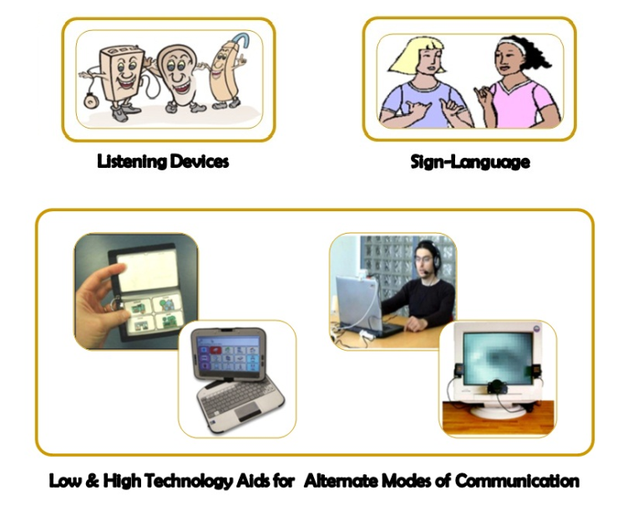

*Figure 16:* Assistive and alternative communication for children with multiple disabilities including communication disorders.

**Assistive Technology and Educational Aids for Children with Multiple Disabilities Having Difficulty in Motor Functions**

If children with multiple disabilities have deficiencies in the upper or lower limbs prosthetic aids either cosmetic or functional can be used. Artificial hands or legs that are functional again can be mechanical or bionic in nature, that is make use of muscle power from the stump or muscle power supplemented by electronic stimulation.

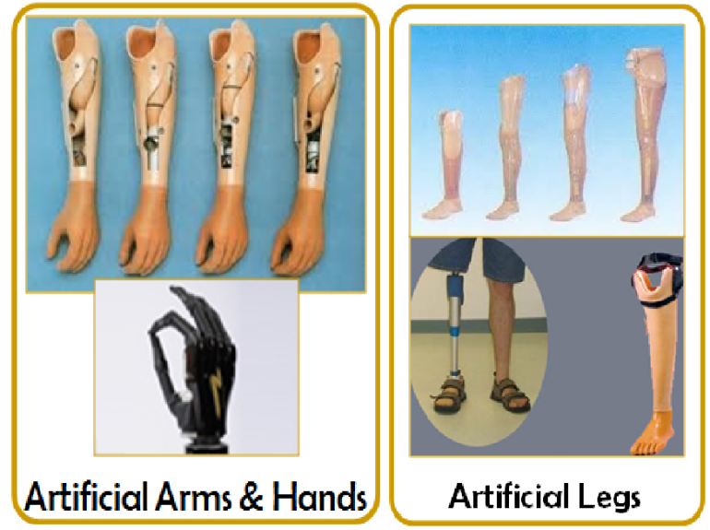

*Figure 17:* Prosthetic aids or artificial limbs for children with multiple disabilities.

If the upper and lower limbs are paralysed and weak, then various types of braces and other orthotic devices can be used to support them according to the level and severity of disability.

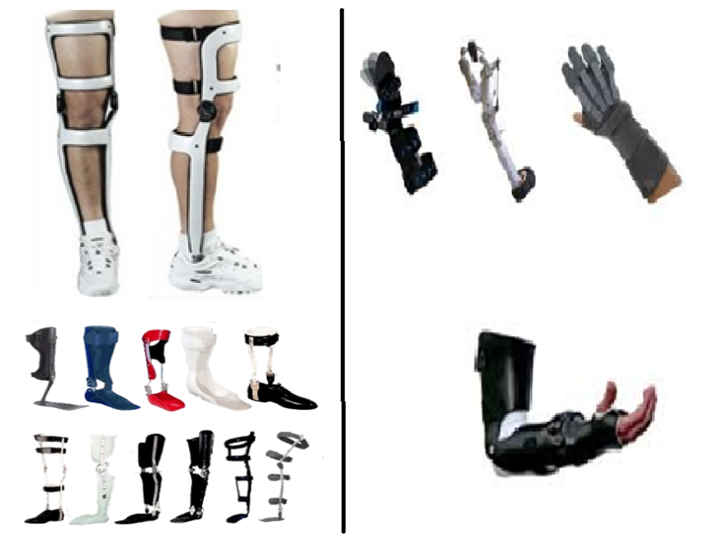

*Figure 18:* Upper and lower limb braces or orthotic aids for children with multiple disabilities.

Even with fitment of necessary orthotic or prosthetic aids for the lower limb, if children with multiple disabilities have difficulty in moving around then suitable mobility devices such as walkers, wheelchairs, hand-operated tricycles, three-wheeled scooters, etc. can be used in indoor or outdoor environments. Similarly if children with multiple disabilities face difficulty in hand functions even with fitment of appropriate orthotic or prosthetic aids then various types of grasping may be helpful in carrying mundane activities as well as learning tasks.

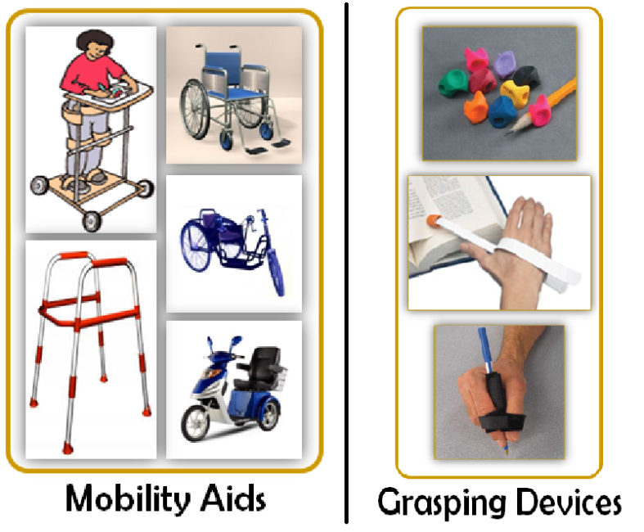

*Figure 19:* Mobility aids and grasping devices for children with multiple disabilities.

**Name**: Rehabilitation and Intervention for Multiple Disabilities – Summary

**Description**:

Figure 20 provides a skeletal outline which will help to recapitulate the information you had gathered about educational rehabilitation and intervention for children with multiple disabilities.

*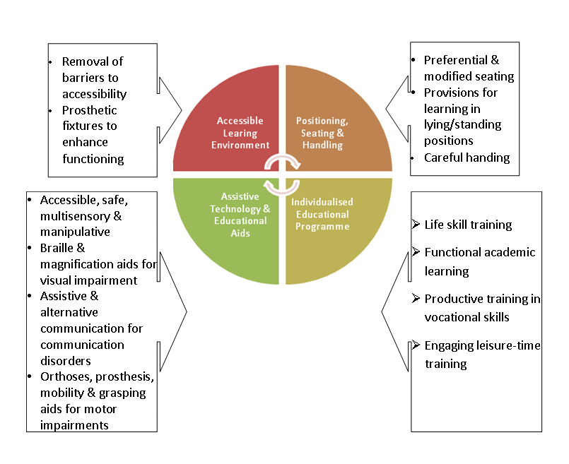Figure 20:* Outline of educational rehabilitation and intervention for children with multiple disabilities.